Programming Fundamentals (CS-303) | Assignment 1



MUHAMMAD NAWAZ SHAREEF
UNIVERSITY OF AGRICULTURE, MULTAN
DEPARTMENT OF ARTIFICIAL INTELLIGENCE AND DATA SCIENCE
ASSIGNMENT 1
LAB TASKS
Learner Name: RABIA NAWAZ
Department: BS AI & Data Science
Semester: 1st
Section: A
Subject: Programming Fundamentals CS-303
Course Tutor: Mam Rashda
Lab 1:
Task 1: Write a Program that prints your name, roll number and Program on separate lines.
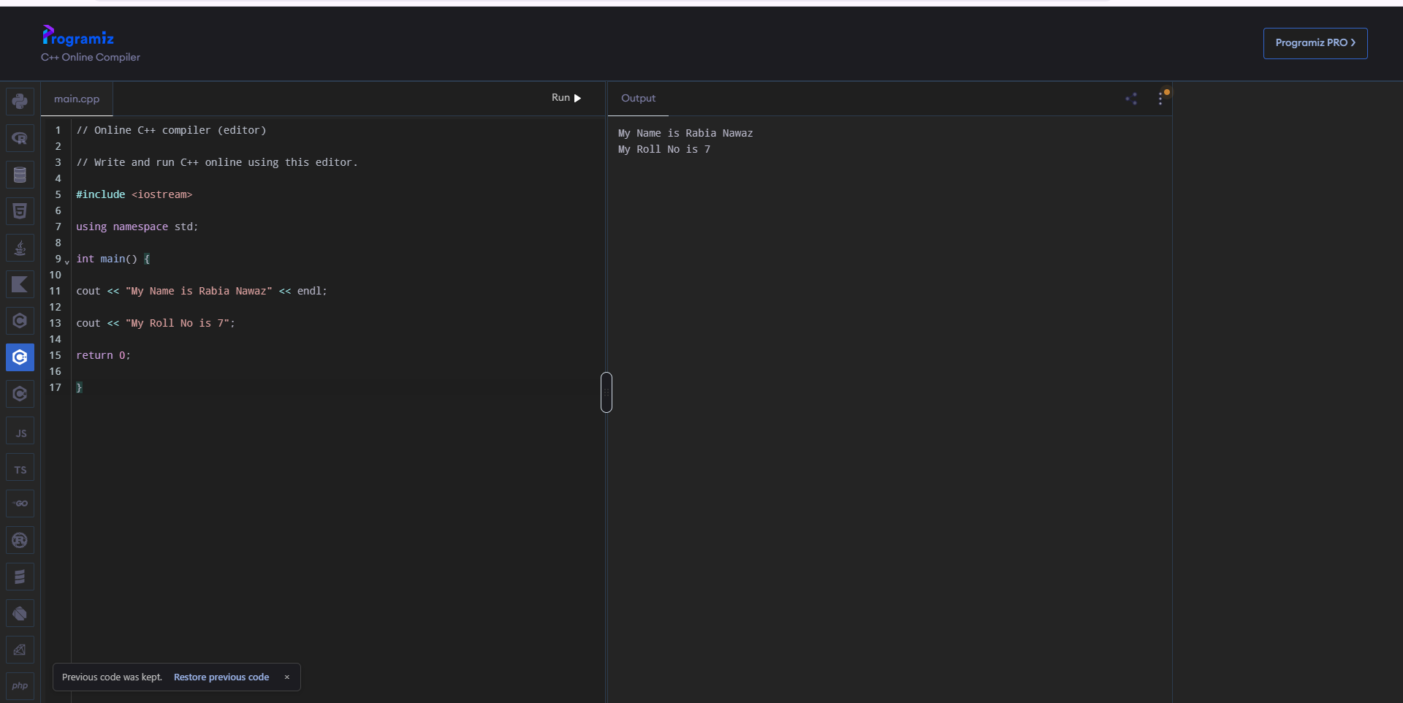
Task 2: Print a box of asterisks 5 rows high and 10 columns wide using cout statements.

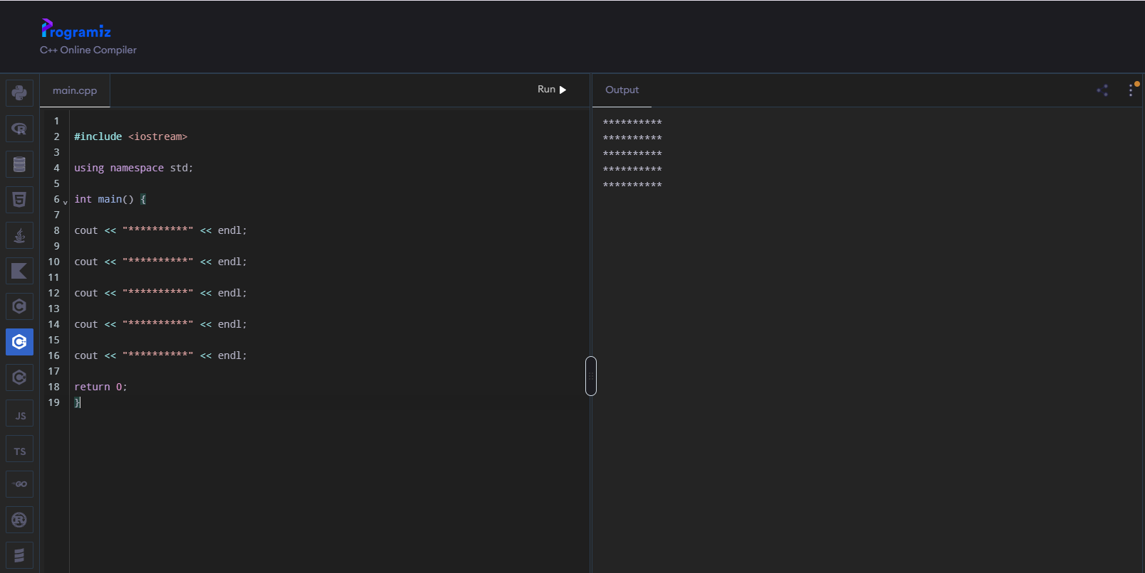

Task 3: Record three different compiler errors and explain what caused each.
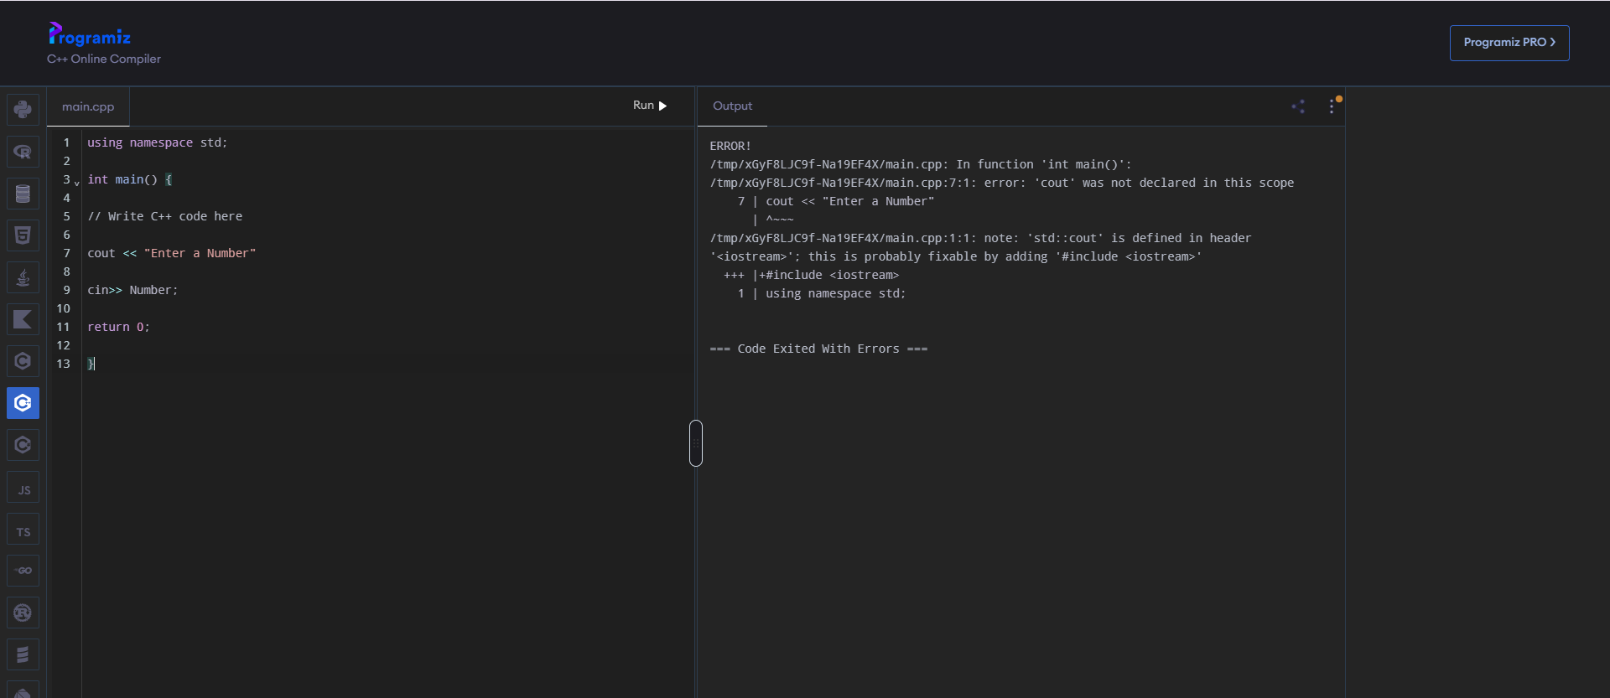
Error 1: Missing iostream Library.
Error 2: Missing Semicolon at the end of cout statement.
Error 3: The variable Named as Number is not decleared.

Lab 2:
Task 1: Read the length and width of a field in metres and print its area in square metres and in kanals (1 kanal = 505.857 m²).
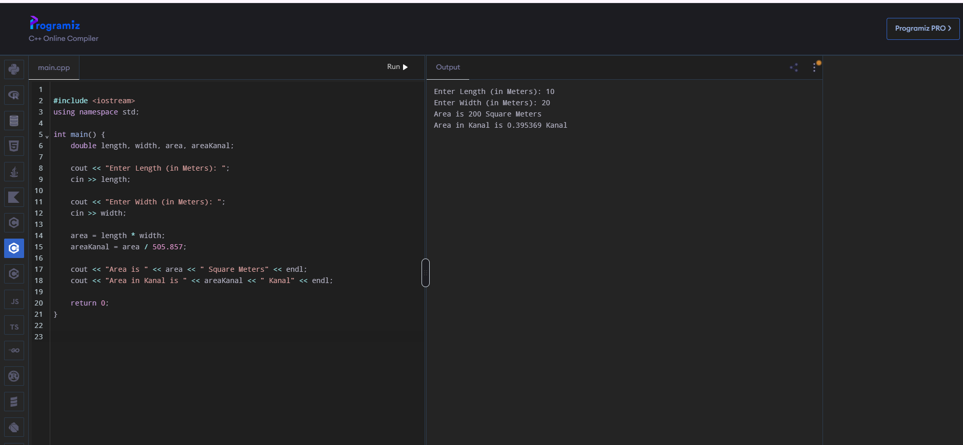

Task 2: Read temperature in Celsius and print it in Fahrenheit and Kelvin with two decimal places.

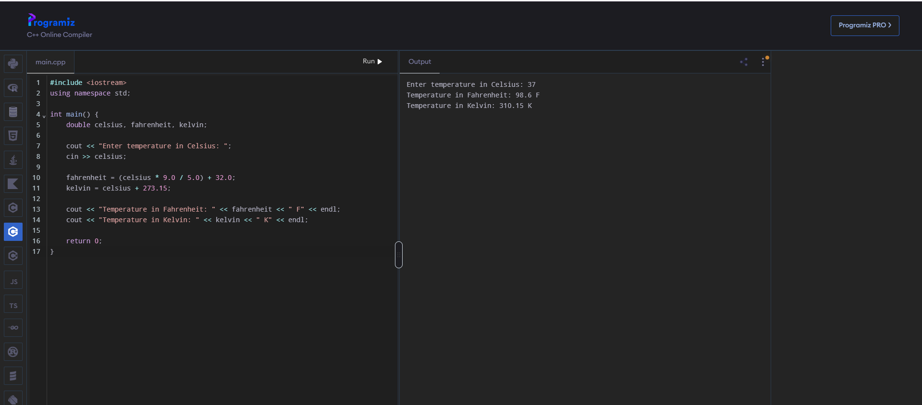

Task 3: Read a number of seconds and print it as hours, minutes and seconds using / and %.

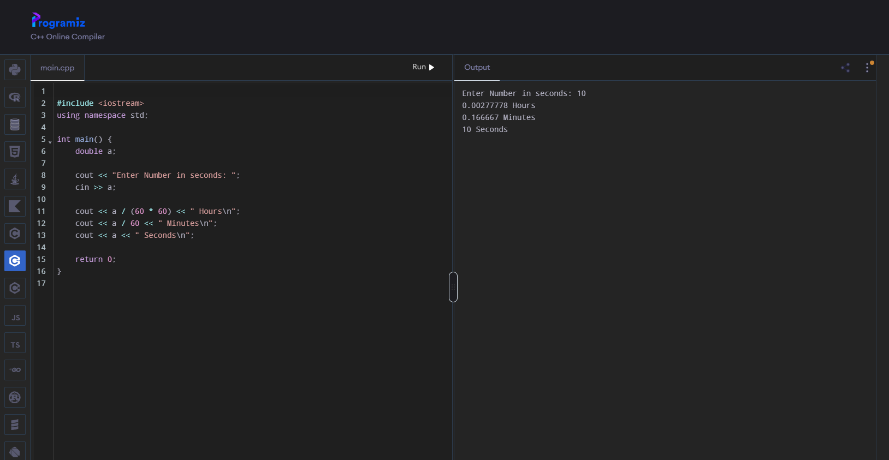

Task 4: Demonstrate overflow by adding 1 to INT_MAX and explain the result.

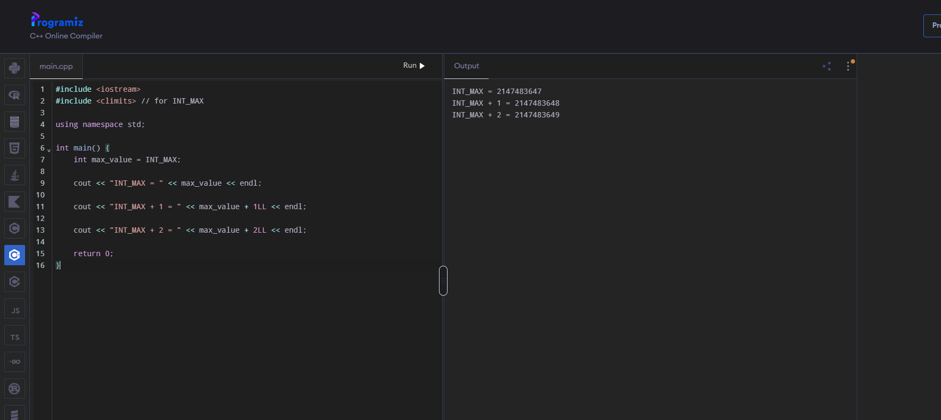

Explanation:
Adding 1 to INT_MAX (2,147,483,647) causes integer overflow because a 32-bit signed int can only hold values up to 2³¹−1. In binary, INT_MAX is 0111...1111; adding 1 carries through all bits and flips the sign bit, giving 1000...0000, which in two's complement equals INT_MIN (−2,147,483,648). So the value wraps around from largest positive to smallest negative, like an odometer rolling from 9999 to 0000. (Note: in standard C++, signed overflow is technically undefined behavior — the wraparound is just what most compilers do.)

Lab 3:
Task 1: Read three numbers and print the largest using nested if.

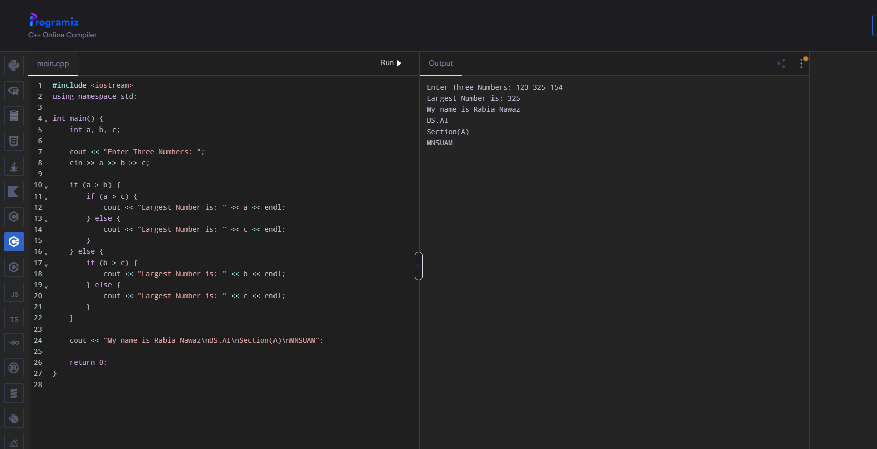
Task 2: Write a grade calculator for marks 0–100 using the grading scheme of the University semester rules.
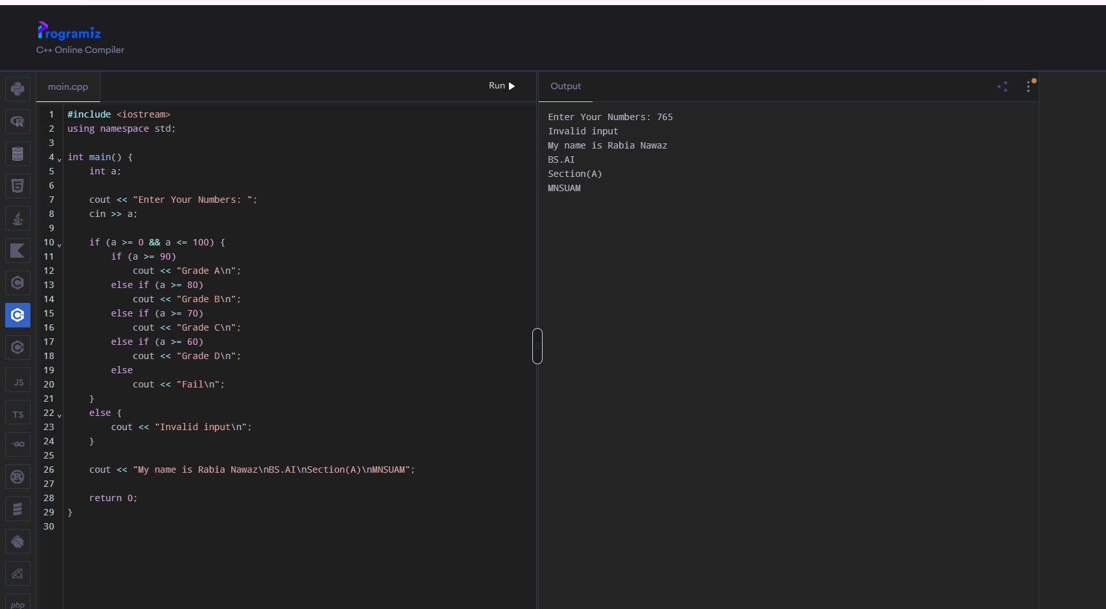
Task 3: Write a menu-driven calculator (+, −, ×, ÷) using switch, handling division by zero.
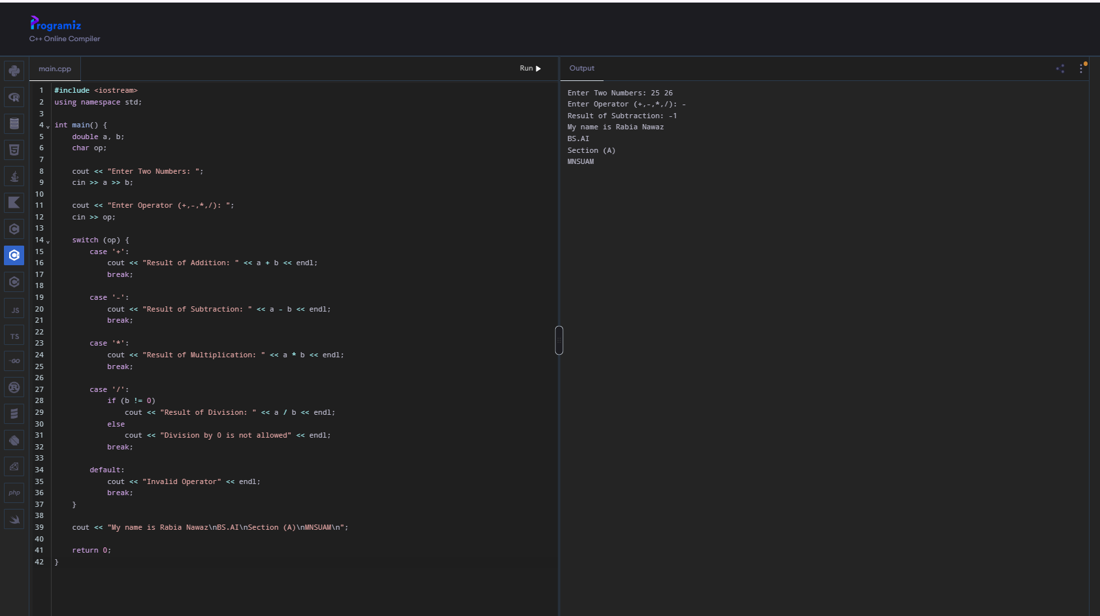

Task 4: Determine whether a year is a leap year.

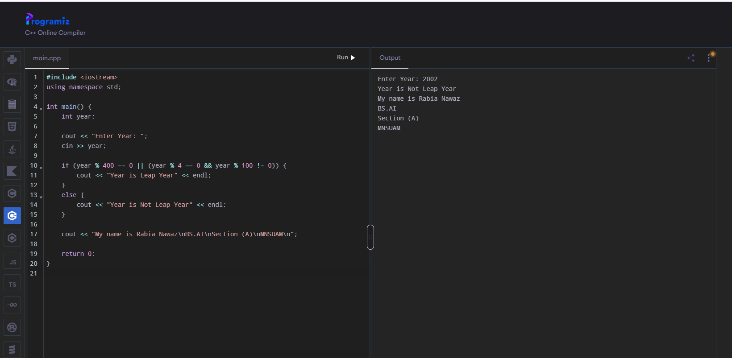

Lab 4:
Task 1: Print all prime numbers between 1 and 200.

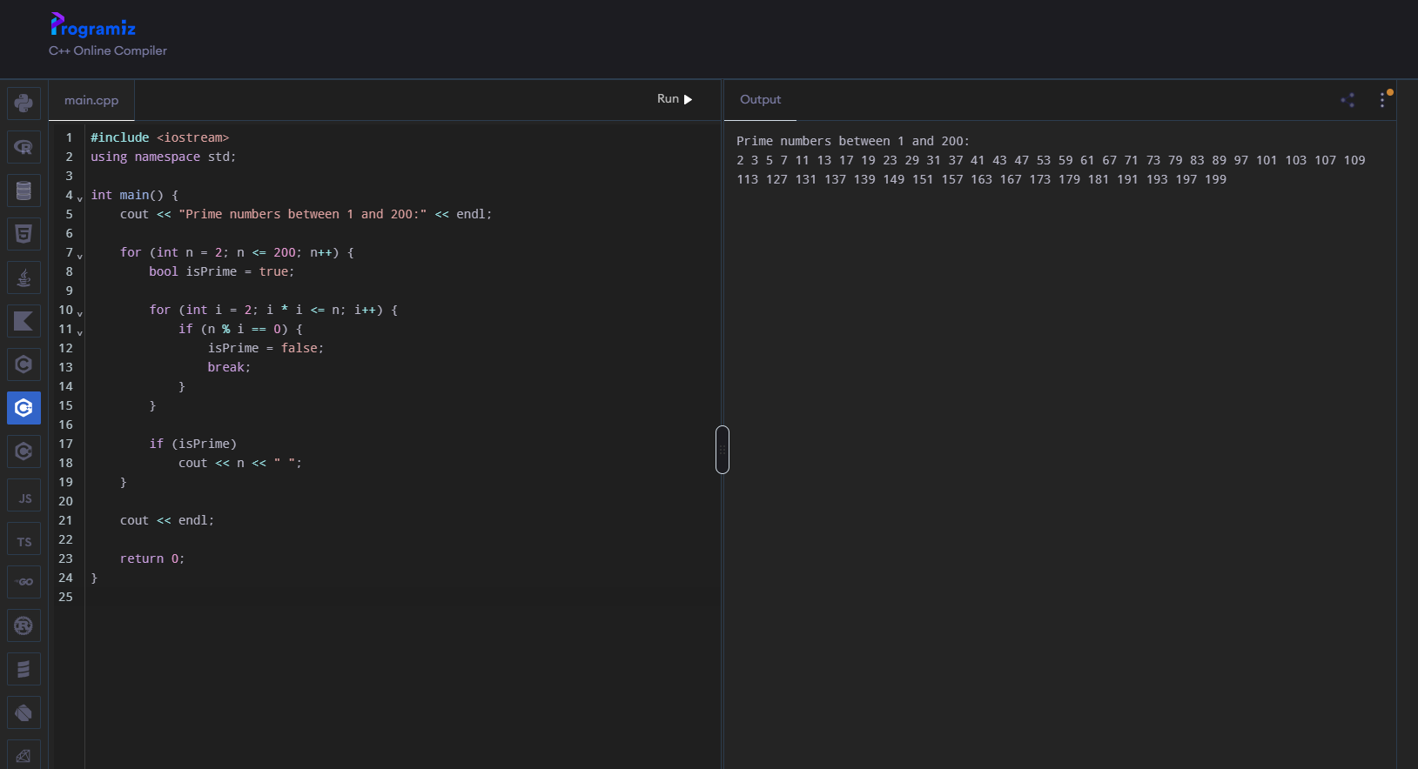
Task 2: Print a right-angled triangle and a pyramid of stars with n rows. 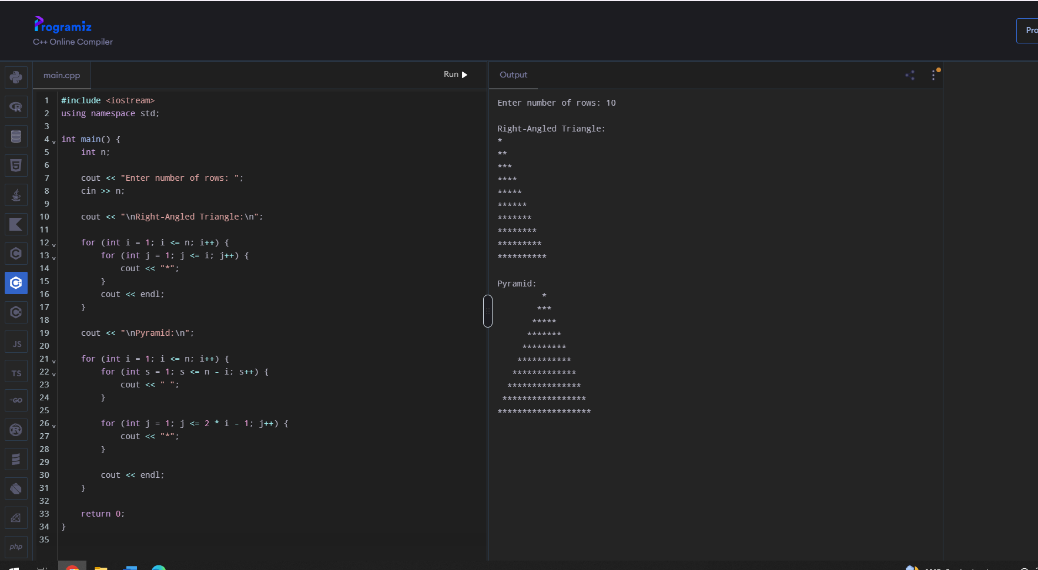

Task 3: Compute the factorial and the sum of digits of a number.

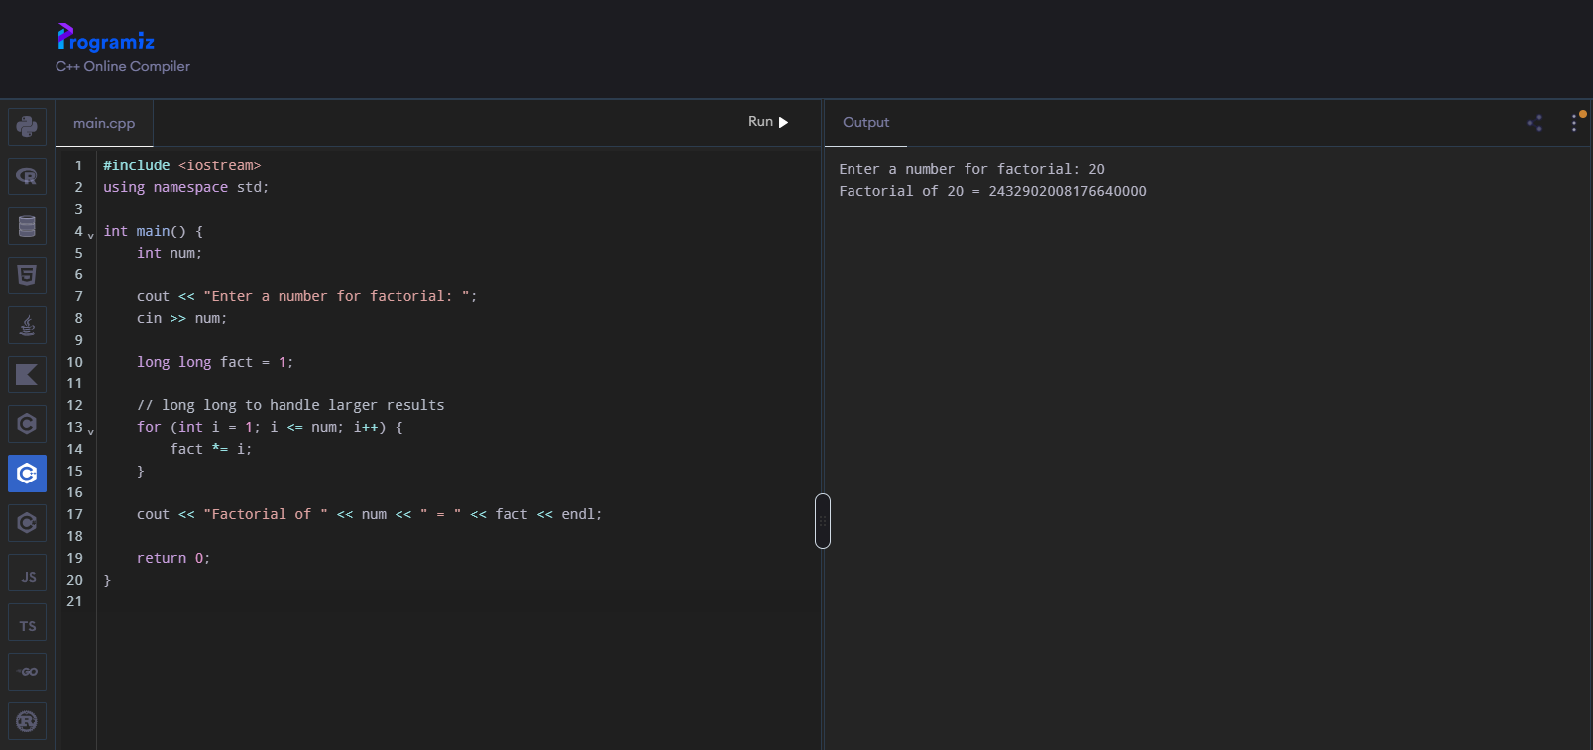

Task 4: Implement a number-guessing game with at most seven attempts.

